Chapter 6 Types of Construction
CALIFORNIA BUILDING CODE — MATRIX ADOPTION TABLE
CHAPTER 6 — TYPES OF CONSTRUCTION
(Matrix Adoption Tables are nonregulatory, intended only as an aid to the code user.
See Chapter 1 for state agency authority and building applications.)
Adopting agency | BSC | BSC  -CG | SFM | HCD |  |  | DSA |  |  | OSHPD |  |  |  |  |  |  | BSCC | DPH | AGR | DWR | CEC | CA | SL | SLC
 |  |  |  | 1 | 2 | 1/AC | AC | SS | SS/CC | 1 | 1R | 2 | 3 | 4 | 5 | 6
Adopt entire chapter | X |  |  |  |  |  |  | X | X | X | X | X | X | X | X | X
Adopt entire chapter as amended (amended sections listed below) |  |  | X | X | X
Adopt only those sections that are listed below
Chapter / Section
Table 601 |  |  | X
602.1 |  |  | X
Table 602 |  |  | X
602.4.1.5 |  |  |  | X | X
602.4.2.5 |  |  |  | X | X
602.4.3.5 |  |  |  | X | X
602.4.4.3 |  |  |  | X | X
603.1 |  |  |  | X | X
603.1.3 |  |  |  | X | X
The state agency does not adopt sections identified with the following symbol: †
The Office of the State Fire Marshal's adoption of this chapter or individual sections is applicable to structures regulated by other state agencies pursuant to Section 1.11.
User notes:
About this chapter: Chapter 6 establishes five types of construction in which each building must be categorized. This chapter looks at the materials used in the building (combustible or noncombustible) and the extent to which building elements such as the building frame, roof, wall and floor can resist fire. Depending on the type of construction and the specific building element, fire resistance of 1 to 3 hours is specified.
ICC code development note: Code change proposals to sections in this chapter will be considered by one of the code development committees meeting during the 2025 (Group B) Code Development Cycle.
Section 601 General
Assembly
Diagram
TABLE 601—FIRE-RESISTANCE RATING REQUIREMENTS FOR BUILDING ELEMENTS (HOURS)
BUILDING ELEMENT | TYPE I |  | TYPE II |  | TYPE III |  | TYPE IV |  |  |  | TYPE V
BUILDING ELEMENT | A | B | A | B | A | B | A | B | C | HT | A | B
Primary structural frame^{f}  (see Section 202) | 3^{a, b} | 2^{a, b, c} | 1^{b, c} | 0^{c} | 1^{b, c} | 0 | 3ª | 2ª | 2ª | HT | 1^{b, c} | 0
Bearing walls
Exterior ^{e, f} | 3 | 2 | 1 | 0 | 2 | 2 | 3 | 2 | 2 | 2 | 1 | 0
Interior | 3ª | 2ª | 1 | 0 | 1 | 0 | 3 | 2 | 2 | 1/HT^{g} | 1 | 0
Nonbearing walls and partitions  Exterior | See Table 705.5
Nonbearing walls and partitions  Interior^{d} | 0 | 0 | 0 | 0 | 0 | 0 | 0 | 0 | 0 | See  Section  2304.11.2 | 0 | 0
Floor construction and associated  secondary structural members (see  Section 202) | 2 | 2 | 1 | 0 | 1 | 0 | 2 | 2 | 2 | HT | 1 | 0
Roof construction and associated  secondary structural members  (see Section 202) | 1¹/₂^{b} | 1^{b,c} | 1^{b,c} | 0^{c} | 1^{b,c} | 0 | 1¹/₂ | 1 | 1 | HT | 1^{b,c} | 0
For SI: 1 foot = 304.8 mm.
- Roof supports: Fire-resistance ratings of primary structural frame and bearing walls are permitted to be reduced by 1 hour where supporting a roof only.

  - Except in Group A, E, F-1, H, I, L, M, R-1, R-2, R-2.1 and S-1 occupancies, high-rise buildings, and other applications listed in Section 1.11 regulated by the Office of the State Fire Marshal, fire protection of structural members in roof construction shall not be required, including protection of primary structural frame members, roof framing and decking where every part of the roof construction is 20 feet or more above any floor or mezzanine immediately below. Fire-retardant-treated wood members shall be allowed to be used for such unprotected members.
  - For Group A, E, I, L, R-1, R-2 and R-2.1 occupancies, high-rise buildings, and other applications listed in Section 1.11 regulated by the Office of the State Fire Marshal, fire protection of members other than the primary structural frame shall not be required, including protection of roof framing and decking where every part of the roof construction is 20 feet or more above any floor immediately below. Fire-retardant-treated wood members shall be allowed to be used for such unprotected members.
  - One-story portions of Group A and E assembly occupancies the roof-framing system of Type II A or Type III A construction may be of unprotected construction when such roof-framing system is open to the assembly area and does not contain concealed spaces.
- In all occupancies, heavy timber complying with Section 2304.11 shall be allowed for roof construction, including primary structural frame members, where a 1-hour or less fire-resistance rating is required.
- Not less than the fire-resistance rating required by other sections of this code.
- Not less than the fire-resistance rating based on fire separation distance (see Table 705.5).
- Not less than the fire-resistance rating as referenced in Section 704.9.
- Heavy timber bearing walls supporting more than two floors or more than a floor and a roof shall have a fire-resistance rating of not less than 1 hour.
UpCodes Diagrams (11)
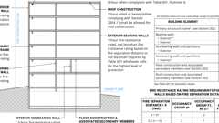
Type IIA Construction
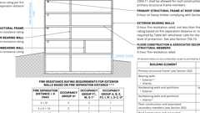
Type IIB Construction
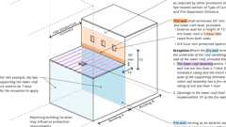
Fire Walls: Stepped Buildings
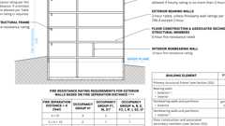
Type IIIB Const.
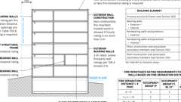
Type IIIA Construction
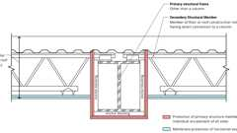
Individual vs. Membrane Protection of Steel Beams
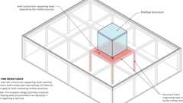
Rooftop Structures: Fire-Resistance Ratings
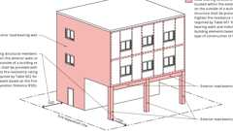
Exterior Structural Member Fire Protection
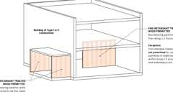
Wood Stud Walls in Type I & II Construction
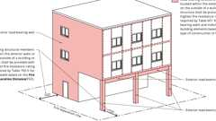
Exterior Structural Member Fire Protection
Show 1 more
Assemblies (123)
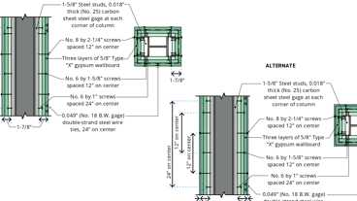
1-7.3: 3hr, Steel Column, Gypsum
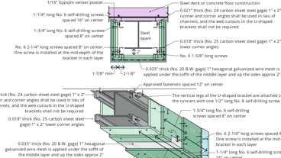
2-4.2: 3hr, Steel Beam, Gypsum - Alt.
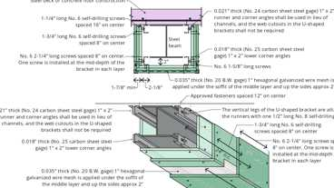
2-4.2: 3hr, Steel Beam, Gypsum
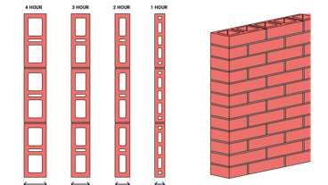
1-1.2: Hollow Brick
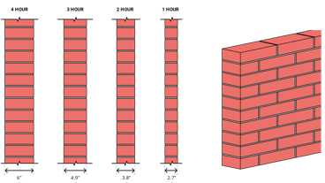
1-1.1: Solid brick
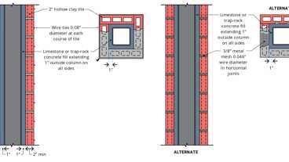
1-3.3: 2hr, Steel Column, Hollow Tile
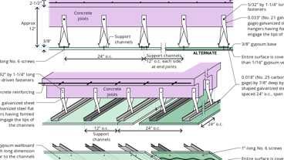
5-2.1: 2hr Reinforced conc.
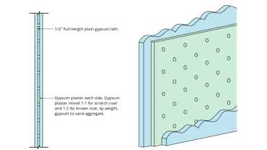
6-2.1: 1hr, Solid Gyp, Studless
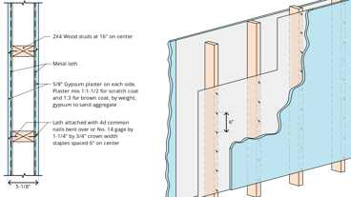
12-1.1: 1hr, Wood
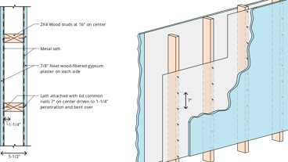
12-1.2: 2hr, Wood
Show 113 more
Building products (9)
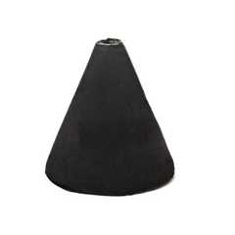
FF109-200 1 Hour Fire Rated LED Downlight Cover
Tenmat

FF109-250 1 Hour Fire Rated LED Downlight Cover
Tenmat

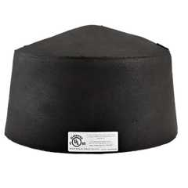
FF109-300 UL Fire Rated Recessed Light Cover
Tenmat

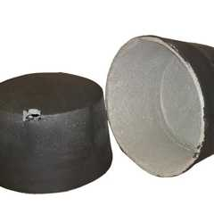
FF109-350 Fire Rated Light Cover
Tenmat

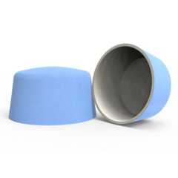
FF109-FRSC 1 Hour Fire Rated Speaker Cover
Tenmat

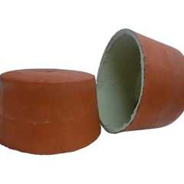
FF109X 2 Hour UL Fire Rated Recessed Light Cover
Tenmat

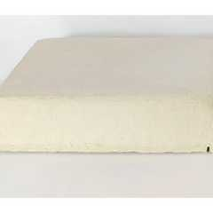
FF130 - 2x2 Fire Rated Troffer Cover
Tenmat

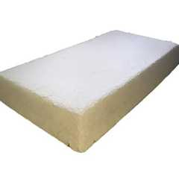
FF130 - 2x4 Fire Rated Troffer Cover
Tenmat

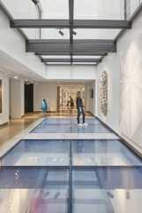
GPX® FireFloor
SaftiFirst

601.1 Scope
The provisions of this chapter shall control the classification of buildings as to type of construction.
Section 602 Construction Classification
Diagram
UpCodes Diagrams (8)
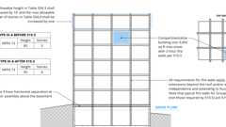
Podiums: Type IIIA Height Increase (2021)
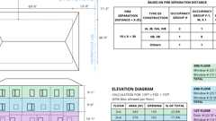
Openings In Ext. Walls at Lot Lines
Type IIA Construction
Type IIB Construction
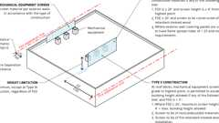
Mechanical Equipment Screens
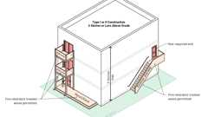
Type I / II: Exterior Areas Using Fire-Retardant Treated Wood
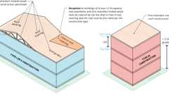
Type I / II Construction: Fire-Retardant Treated Wood Roof Construction
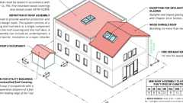
Roof Assembly Fire Classification
602.1 General
Assembly
Diagram
Buildings and structures erected or to be erected, altered or extended in height or area shall be classified in one of the five construction types defined in Sections 602.2 through 602.5. The building elements shall have a fire-resistance rating not less than that specified in Table 601 and exterior walls shall have a fire-resistance rating not less than that specified in Table 705.5. Where required to have a fire-resistance rating by Table 601, building elements shall comply with the applicable provisions of Section 703.2. The protection of openings, ducts and air transfer openings in building elements shall not be required unless required by other provisions of this code.
Exception: Noncombustible structural members supporting solar photovoltaic panels are not required to meet the fire resistance rating for the following:
- Photovoltaic panel supported by a structure and having no use underneath. Signs may be provided, as determined by the enforcing agency prohibiting any use underneath including storage.
- Solar photovoltaic (PV) panels supported by noncombustible framing that have sufficient uniformly distributed and unobstructed openings throughout the top of the array (horizontal plane) to allow heat and gases to escape, as determined by the enforcing agency.
- Solar photovoltaic panels supported by a structure over parking stalls where the panels constitute the roof and all the following conditions are met (see Figure 5-1):
  - The area within the perimeter of the solar photovoltaic array has maximum rectangular dimension of 40 feet by 150 feet.
  - The distance between solar photovoltaic array structures is a minimum of 10 feet clear.
  - The driveway aisle separating solar photovoltaic array structures has a minimum width of 25 feet clear.
  - Solar photovoltaic array structure is used only for parking purposes with no storage.
  - Completely open on all sides (other than necessary structural supports) with no interior partitions.
UpCodes Diagrams (3)
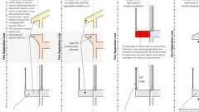
Combustible Projection Construction
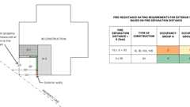
Fire Ratings at Prop. Lines
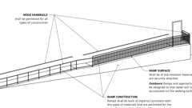
Ramp Construction
Assembly (1)
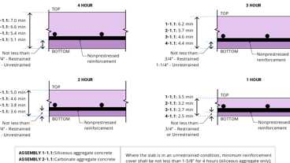
1-1.1 Through 4-1.1: Concrete Slab
602.1.1 Minimum Requirements
A building or portion thereof shall not be required to conform to the details of a type of construction higher than that type which meets the minimum requirements based on occupancy even though certain features of such a building actually conform to a higher type of construction.
602.2 Types I and II
Assembly
Diagram
Types I and II construction are those types of construction in which the building elements specified in Table 601 are of noncombustible materials, except as permitted in Section 603 and elsewhere in this code.
UpCodes Diagrams (12)
Primary
Type IIB Construction
Primary
Type IIA Construction
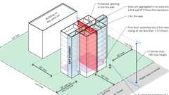
Group R-1 & R-2 Bldgs Type IIA - Height Increase Pt 1
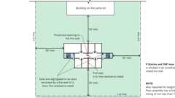
Group R-1 & R-2 Bldgs Type IIA - Height Increase Pt 2
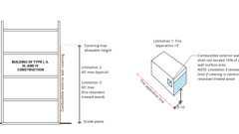
Combustibles on Non-Combustible Ext. Walls: Limitations
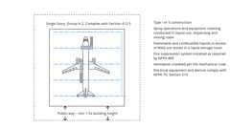
Unlimited Area Paint Hangers
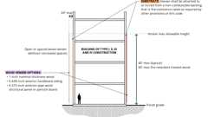
Wood Veneer on Non-Combustible Wall Construction
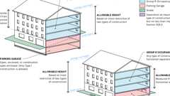
Podiums: Parking Beneath Group R
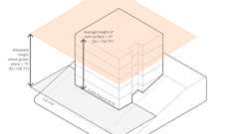
Allowable Height Above Grade Plane
Wood Stud Walls in Type I & II Construction
Show 2 more
Assemblies (16)
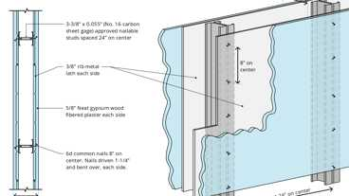
11-1.2: 2hr, Steel Stud/ Plaster
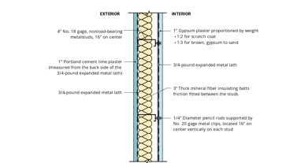
15-1.9: 2hr, Steel Stud
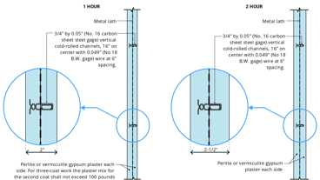
6-1.2: 1hr & 2hr, Solid Gyp Plaster
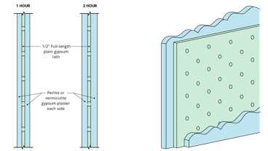
6-2.2: 1hr & 2hr, Solid Gyp
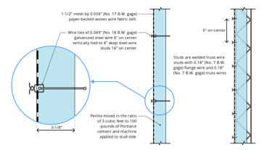
7-1.1: 2hr, Steel Wire
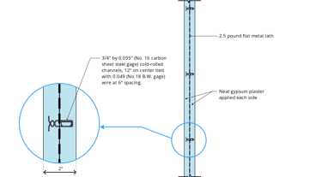
8-1.1: 2hr, Steel
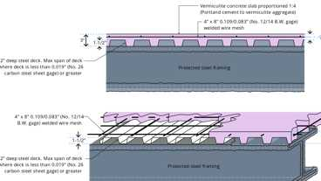
15-1.1: 1hr, Steel, Conc. / Metal Deck
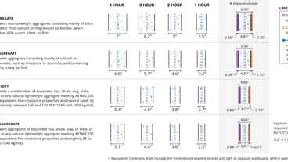
4-1.1: Concrete Walls
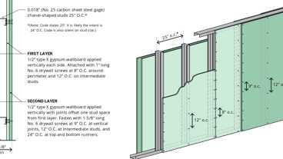
13-1.2: 2hr, Steel Studs
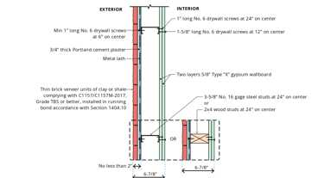
15-2.2: 2hr, Steel or Wood
Show 6 more
Building products (5)
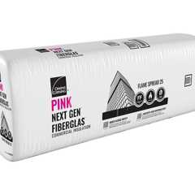
PINK® Next Gen™ Fiberglas™ Flame Spread 25
Owens Corning

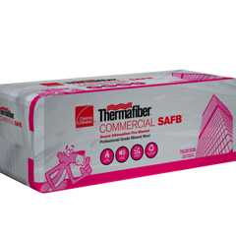
Thermafiber® SAFB™
Owens Corning

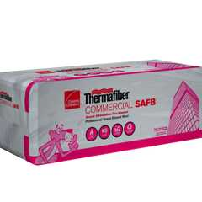
Thermafiber® SAFB™ FF
Owens Corning

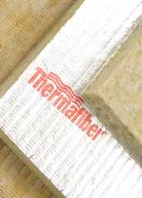
Thermafiber® Safing
Owens Corning

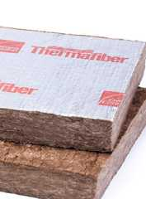
Thermafiber® Safing FF
Owens Corning

602.3 Type III
Assembly
Diagram
Type III construction is that type of construction in which the exterior walls are of noncombustible materials and the interior building elements are of any material permitted by this code. Fire-retardant-treated wood framing and sheathing complying with Section 2303.2 shall be permitted within exterior wall assemblies of a 2-hour rating or less.
UpCodes Diagrams (7)
Primary
Type IIIA Construction
Primary
Type IIIB Const.
Podiums: Type IIIA Height Increase (2021)
Combustibles on Non-Combustible Ext. Walls: Limitations
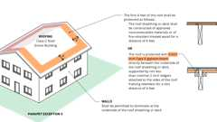
Parapets - Exception 5
Wood Veneer on Non-Combustible Wall Construction
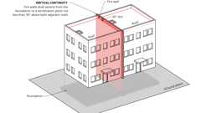
Fire Walls: Vertical Continuity - Base Condition
Assemblies (12)
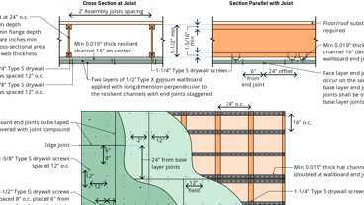
27-1.1: 1hr, I-joist
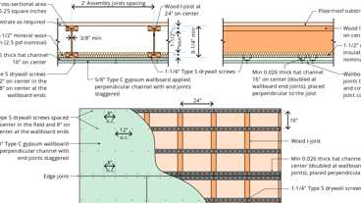
24-1.1: 1hr, I-joist
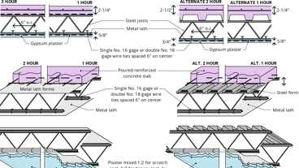
6-1.1: 1hr & 2hr, Steel
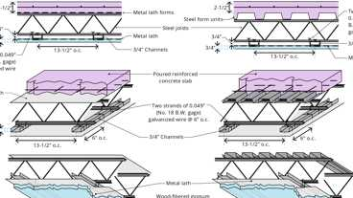
6-5.1: 2hr Steel
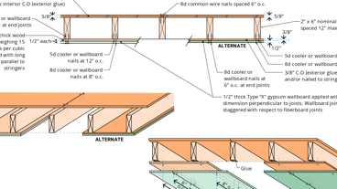
14-1.1: 1hr, Wood Joist
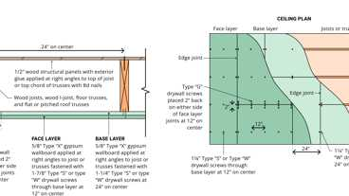
21-1.1: 1hr, Wood Joist
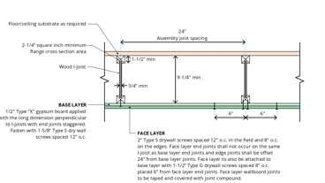
26-1.1: 1hr, I-joist
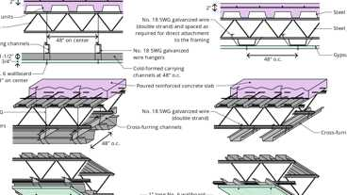
6-4.1: 2hr Steel - Opt. 2 & 3
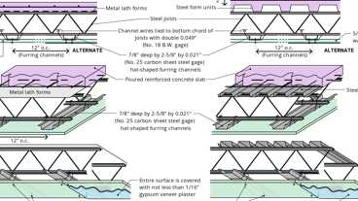
6-4.1: 2hr Steel - Opt. 1
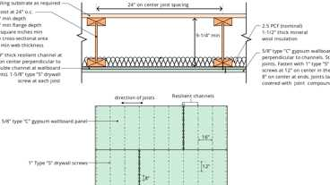
25-1.1: 1hr, I-joist
Show 2 more
Building products (20)
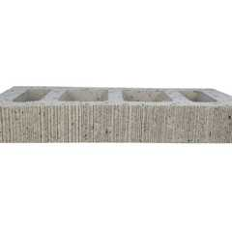
Atlas® 10 x 2¼ x 16
Interstate Brick

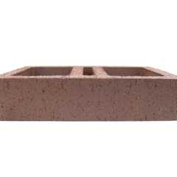
Atlas® 10 x 4 x 16
Interstate Brick

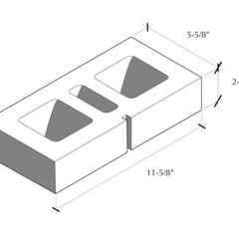
Atlas® 6 x 2¼ x 12
Interstate Brick

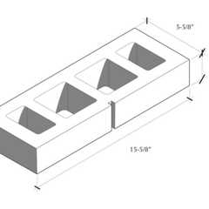
Atlas® 6 x 2¼ x 16
Interstate Brick

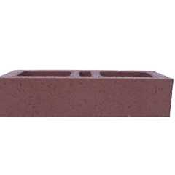
Atlas® 6 x 4 x 16
Interstate Brick

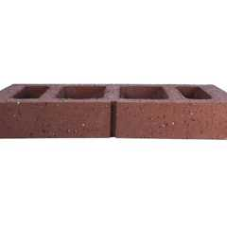
Atlas® 8 x 2¼ x 16
Interstate Brick

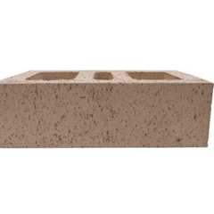
Atlas® 8 x 4 x 12
Interstate Brick

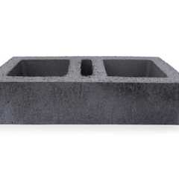
Atlas® 8 x 4 x 16
Interstate Brick

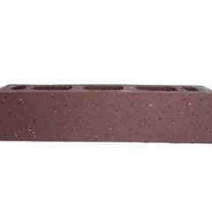
Atlas® Emperor 4 x 4 x 16
Interstate Brick

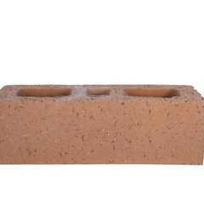
Atlas® Utility 4 x 4 x 12
Interstate Brick

FF109-200 1 Hour Fire Rated LED Downlight Cover
Tenmat

FF109-250 1 Hour Fire Rated LED Downlight Cover
Tenmat

FF109-300 UL Fire Rated Recessed Light Cover
Tenmat

FF109-350 Fire Rated Light Cover
Tenmat

FF109-FRSC 1 Hour Fire Rated Speaker Cover
Tenmat

FF109X 2 Hour UL Fire Rated Recessed Light Cover
Tenmat

FF130 - 2x2 Fire Rated Troffer Cover
Tenmat

FF130 - 2x4 Fire Rated Troffer Cover
Tenmat

PINK® Next Gen™ Fiberglas™ Flame Spread 25
Owens Corning

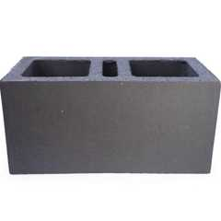
Super Atlas® 8 x 8 x16
Interstate Brick

602.4 Type IV
Assembly
Diagram
Type IV construction is that type of construction in which the building elements are mass timber or noncombustible materials and have fire-resistance ratings in accordance with Table 601. Mass timber elements shall meet the fire-resistance-rating requirements of this section based on either the fire-resistance rating of the noncombustible protection, the mass timber, or a combination of both and shall be determined in accordance with Section 703.2. The minimum dimensions and permitted materials for building elements shall comply with the provisions of this section and Section 2304.11. Mass timber elements of Types IV-A, IV-B and IV-C construction shall be protected with noncombustible protection applied directly to the mass timber in accordance with Sections 602.4.1 through 602.4.3. The time assigned to the noncombustible protection shall be determined in accordance with Section 703.6 and comply with Section 722.7.
Cross-laminated timber shall be labeled as conforming to ANSI/APA PRG 320 as referenced in Section 2303.1.4.
Exterior load-bearing walls and nonload-bearing walls shall be mass timber construction, or shall be of noncombustible construction.
Exception: Exterior load-bearing walls and nonload-bearing walls of Type IV-HT Construction in accordance with Section 602.4.4.
The interior building elements, including nonload-bearing walls and partitions, shall be of mass timber construction or of noncombustible construction.
Exception: Interior building elements and nonload-bearing walls and partitions of Type IV-HT construction in accordance with Section 602.4.4.
Combustible concealed spaces are not permitted except as otherwise indicated in Sections 602.4.1 through 602.4.4.
Combustible stud spaces within light frame walls of Type IV-HT construction shall not be considered concealed spaces, but shall comply with Section 718.
In buildings of Type IV-A, IV-B, and IV-C construction with an occupied floor located more than 75 feet (22 860 mm) above the lowest level of fire department vehicle access, up to and including 12 stories or 180 feet (54 864 mm) above grade plane, mass timber interior exit and elevator hoistway enclosures shall be protected in accordance with Section 602.4.1.2. In buildings greater than 12 stories or 180 feet (54 864 mm) above grade plane, interior exit and elevator hoistway enclosures shall be constructed of noncombustible materials.
UpCodes Diagrams (5)
Combustibles on Non-Combustible Ext. Walls: Limitations
Parapets - Exception 5
Wood Veneer on Non-Combustible Wall Construction
Podiums: Parking Beneath Group R
Fire Walls: Vertical Continuity - Base Condition
Assemblies (2)
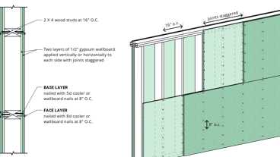
14-1.2: 1hr, Wood
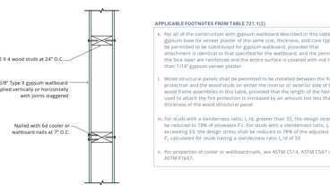
14-1.3: 1hr, Wood
Building products (12)
Atlas® 10 x 2¼ x 16
Interstate Brick

Atlas® 10 x 4 x 16
Interstate Brick

Atlas® 6 x 2¼ x 12
Interstate Brick

Atlas® 6 x 2¼ x 16
Interstate Brick

Atlas® 6 x 4 x 16
Interstate Brick

Atlas® 8 x 2¼ x 16
Interstate Brick

Atlas® 8 x 4 x 12
Interstate Brick

Atlas® 8 x 4 x 16
Interstate Brick

Atlas® Emperor 4 x 4 x 16
Interstate Brick

Atlas® Utility 4 x 4 x 12
Interstate Brick

PINK® Next Gen™ Fiberglas™ Flame Spread 25
Owens Corning

Super Atlas® 8 x 8 x16
Interstate Brick

602.4.1 Type IV-A
Building elements in Type IV-A construction shall be protected in accordance with Sections 602.4.1.1 through 602.4.1.6. The required fire-resistance rating of noncombustible elements and protected mass timber elements shall be determined in accordance with Section 703.2.
602.4.1.1 Exterior Protection
The outside face of exterior walls of mass timber construction shall be protected with noncombustible protection with a minimum assigned time of 40 minutes, as specified in Table 722.7.1(1). Components of the exterior wall covering shall be of noncombustible material except water-resistive barriers having a peak heat release rate of less than 150kW/m², a total heat release of less than 20 MJ/m² and an effective heat of combustion of less than 18MJ/kg as determined in accordance with ASTM E1354 and having a flame spread index of 25 or less and a smoke-developed index of 450 or less as determined in accordance with ASTM E84 or UL 723. The ASTM E1354 test shall be conducted on specimens at the thickness intended for use, in the horizontal orientation and at an incident radiant heat flux of 50 kW/m².
602.4.1.2 Interior Protection
Interior faces of all mass timber elements, including the inside faces of exterior mass timber walls and mass timber roofs, shall be protected with materials complying with Section 703.3.
602.4.1.2.1 Protection Time
Noncombustible protection shall contribute a time equal to or greater than times assigned in Table 722.7.1(1), but not less than 80 minutes. The use of materials and their respective protection contributions specified in Table 722.7.1(2) shall be permitted to be used for compliance with Section 722.7.1.
602.4.1.3 Floors
The floor assembly shall contain a noncombustible material not less than 1 inch (25 mm) in thickness above the mass timber. Floor finishes in accordance with Section 804 shall be permitted on top of the noncombustible material. The underside of floor assemblies shall be protected in accordance with Section 602.4.1.2.
602.4.1.4 Roofs
The interior surfaces of roof assemblies shall be protected in accordance with Section 602.4.1.2. Roof coverings in accordance with Chapter 15 shall be permitted on the outside surface of the roof assembly.
602.4.1.5 Concealed Spaces
Diagram
Concealed spaces shall not contain combustibles other than electrical, mechanical, fire protection, or plumbing materials and equipment permitted in plenums in accordance with the California Mechanical Code, and shall comply with all applicable provisions of Section 718. Combustible construction forming concealed spaces shall be protected in accordance with Section 602.4.1.2.
UpCodes Diagram (1)
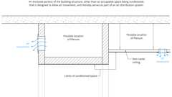
Plenum (definition)
602.4.1.6 Shafts
Shafts shall be permitted in accordance with Sections 713 and 718. Both the shaft side and room side of mass timber elements shall be protected in accordance with Section 602.4.1.2.
602.4.2 Type IV-B
Building elements in Type IV-B construction shall be protected in accordance with Sections 602.4.2.1 through 602.4.2.6. The required fire-resistance rating of noncombustible elements or mass timber elements shall be determined in accordance with Section 703.2.
602.4.2.1 Exterior Protection
The outside face of exterior walls of mass timber construction shall be protected with noncombustible protection with a minimum assigned time of 40 minutes, as specified in Table 722.7.1(1). Components of the exterior wall covering shall be of noncombustible material except water-resistive barriers having a peak heat release rate of less than 150kW/m², a total heat release of less than 20 MJ/m² and an effective heat of combustion of less than 18MJ/kg as determined in accordance with ASTM E1354, and having a flame spread index of 25 or less and a smoke-developed index of 450 or less as determined in accordance with ASTM E84 or UL 723. The ASTM E1354 test shall be conducted on specimens at the thickness intended for use, in the horizontal orientation and at an incident radiant heat flux of 50 kW/m².
602.4.2.2 Interior Protection
Interior faces of all mass timber elements, including the inside face of exterior mass timber walls and mass timber roofs, shall be protected, as required by this section, with materials complying with Section 703.3.
602.4.2.2.1 Protection Time
Noncombustible protection shall contribute a time equal to or greater than times assigned in Table 722.7.1(1), but not less than 80 minutes. The use of materials and their respective protection contributions specified in Table 722.7.1(2) shall be permitted to be used for compliance with Section 722.7.1.
602.4.2.2.2 Protected Area
Interior faces of mass timber elements, including the inside face of exterior mass timber walls and mass timber roofs, shall be protected in accordance with Section 602.4.2.2.1.
Exceptions: Unprotected portions of mass timber ceilings and walls complying with Section 602.4.2.2.4 and the following:
- Unprotected portions of mass timber ceilings and walls complying with one of the following:
  - Unprotected portions of mass timber ceilings, including attached beams, limited to an area less than or equal to 100 percent of the floor area in any dwelling unit within a story or fire area within a story.
  - Unprotected portions of mass timber walls, including attached columns, limited to an area less than or equal to 40 percent of the floor area in any dwelling unit within a story or fire area within a story.
  - Unprotected portions of both walls and ceilings of mass timber, including attached columns and beams, in any dwelling unit or fire area and in compliance with Section 602.4.2.2.3.
- Mass timber columns and beams that are not an integral portion of walls or ceilings, respectively, without restriction of either aggregate area or separation from one another.
602.4.2.2.3 Mixed Unprotected Areas
In each dwelling unit or fire area, where both portions of ceilings and portions of walls are unprotected, the total allowable unprotected area shall be determined in accordance with Equation 6-1.
Equation 6-1
where:
U_{tc} = Total unprotected mass timber ceiling areas.
U_{ac} = Allowable unprotected mass timber ceiling area conforming to Exception 1.1 of Section 602.4.2.2.2.
U_{tw} = Total unprotected mass timber wall areas.
U_{aw}= Allowable unprotected mass timber wall area conforming to Exception 1.2 of Section 602.4.2.2.2.
602.4.2.2.4 Separation Distance Between Unprotected Mass Timber Elements
In each dwelling unit or fire area, unprotected portions of mass timber walls shall be not less than 15 feet (4572 mm) from unprotected portions of other walls measured horizontally along the floor.
602.4.2.3 Floors
The floor assembly shall contain a noncombustible material not less than 1 inch (25 mm) in thickness above the mass timber. Floor finishes in accordance with Section 804 shall be permitted on top of the noncombustible material. Except where unprotected mass timber ceilings are permitted in Section 602.4.2.2.2, the underside of floor assemblies shall be protected in accordance with Section 602.4.1.2.
602.4.2.4 Roofs
The interior surfaces of roof assemblies shall be protected in accordance with Section 602.4.2.2 except, in nonoccupiable spaces, they shall be treated as a concealed space with no portion left unprotected. Roof coverings in accordance with Chapter 15 shall be permitted on the outside surface of the roof assembly.
602.4.2.5 Concealed Spaces
Concealed spaces shall not contain combustibles other than electrical, mechanical, fire protection, or plumbing materials and equipment permitted in plenums in accordance with the California Mechanical Code, and shall comply with all applicable provisions of Section 718. Combustible construction forming concealed spaces shall be protected in accordance with Section 602.4.1.2.
602.4.2.6 Shafts
Shafts shall be permitted in accordance with Sections 713 and 718. Both the shaft side and room side of mass timber elements shall be protected in accordance with Section 602.4.1.2.
602.4.3 Type IV-C
Building elements in Type IV-C construction shall be protected in accordance with Sections 602.4.3.1 through 602.4.3.6. The required fire-resistance rating of building elements shall be determined in accordance with Section 703.2.
602.4.3.1 Exterior Protection
The exterior side of walls of combustible construction shall be protected with noncombustible protection with a minimum assigned time of 40 minutes, as determined in Table 722.7.1(1). Components of the exterior wall covering shall be of noncombustible material except water-resistive barriers having a peak heat release rate of less than 150 kW/m², a total heat release of less than 20 MJ/m² and an effective heat of combustion of less than 18 MJ/kg as determined in accordance with ASTM E1354 and having a flame spread index of 25 or less and a smoke-developed index of 450 or less as determined in accordance with ASTM E84 or UL 723. The ASTM E1354 test shall be conducted on specimens at the thickness intended for use, in the horizontal orientation and at an incident radiant heat flux of 50 kW/m².
602.4.3.2 Interior Protection
Mass timber elements are permitted to be unprotected.
602.4.3.3 Floors
Floor finishes in accordance with Section 804 shall be permitted on top of the floor construction.
602.4.3.4 Roof Coverings
Roof coverings in accordance with Chapter 15 shall be permitted on the outside surface of the roof assembly.
602.4.3.5 Concealed Spaces
Diagram
Concealed spaces shall not contain combustibles other than electrical, mechanical, fire protection, or plumbing materials and equipment permitted in plenums in accordance with the California Mechanical Code, and shall comply with all applicable provisions of Section 718. Combustible construction forming concealed spaces shall be protected with noncombustible protection with a minimum assigned time of 40 minutes, as specified in Table 722.7.1(1).
UpCodes Diagram (1)
Plenum (definition)
602.4.3.6 Shafts
Shafts shall be permitted in accordance with Sections 713 and 718. Shafts and elevator hoistway and interior exit stairway enclosures shall be protected with noncombustible protection with a minimum assigned time of 40 minutes, as specified in Table 722.7.1(1), on both the inside of the shaft and the outside of the shaft.
602.4.4 Type IV-HT
Type IV-HT (Heavy Timber) construction is that type of construction in which the exterior walls are of noncombustible materials and the interior building elements are of solid wood, laminated heavy timber or structural composite lumber (SCL), without concealed spaces or with concealed spaces complying with Section 602.4.4.3. The minimum dimensions for permitted materials including solid timber, glued-laminated timber, SCL and cross-laminated timber (CLT) and the details of Type IV construction shall comply with the provisions of this section and Section 2304.11. Exterior walls complying with Section 602.4.4.1 or 602.4.4.2 shall be permitted. Interior walls and partitions not less than 1-hour fire-resistance rated or heavy timber conforming with Section 2304.11.2.2 shall be permitted.
602.4.4.1 Fire-Retardant-Treated Wood in Exterior Walls
Fire-retardant-treated wood framing and sheathing complying with Section 2303.2 shall be permitted within exterior wall assemblies with a 2-hour rating or less.
602.4.4.2 Cross-Laminated Timber in Exterior Walls
Cross-laminated timber (CLT) not less than 4 inches (102 mm) in thickness complying with Section 2303.1.4 shall be permitted within exterior wall assemblies with a 2-hour rating or less. Heavy timber structural members appurtenant to the CLT exterior wall shall meet the requirements of Table 2304.11 and be fire-resistance rated as required for the exterior wall. The exterior surface of the cross-laminated timber and heavy timber elements shall be protected by one of the following:
- Fire-retardant-treated wood sheathing complying with Section 2303.2 and not less than ¹⁵/₃₂ inch (12 mm) thick.
- Gypsum board not less than ¹/₂ inch (12.7 mm) thick.
- A noncombustible material.
602.4.4.3 Concealed Spaces
Concealed spaces shall not contain combustible materials other than building elements and electrical, mechanical, fire protection, or plumbing materials and equipment permitted in plenums in accordance with the California Mechanical Code. Concealed spaces shall comply with applicable provisions of Section 718. Concealed spaces shall be protected in accordance with one or more of the following:
- The building shall be sprinklered throughout in accordance with Section 903.3.1.1 and automatic sprinklers shall also be provided in the concealed space.
- The concealed space shall be completely filled with noncombustible insulation.
- Combustible surfaces within the concealed space shall be fully sheathed with not less than ⁵/₈-inch Type X gypsum board.
Exception: Concealed spaces within interior walls and partitions with a 1-hour or greater fire-resistance rating complying with Section 2304.11.2.2 shall not require additional protection.
Building products (2)
Thermafiber® SAFB™
Owens Corning

Thermafiber® SAFB™ FF
Owens Corning

602.4.4.4 Exterior Structural Members
Where a fire separation distance of 20 feet (6096 mm) or more is provided, wood columns and arches conforming to heavy timber sizes complying with Section 2304.11 shall be permitted to be used externally.
602.5 Type V
Assembly
Diagram
Type V construction is that type of construction in which the structural elements, exterior walls and interior walls are of any materials permitted by this code.
UpCodes Diagrams (8)
Parapets - Exception 5
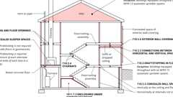
Fireblocking, Draftstopping and Enclosed Space Concepts
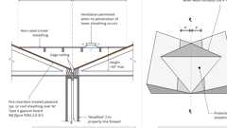
Cricket (Unrated) at Prop. Line
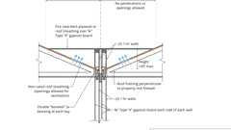
Cricket (Rated) at Prop. Line
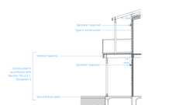
NFPA 13R Sprinklers: Balconies and Decks
Fire Walls: Vertical Continuity - Base Condition
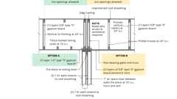
Fire Assembly Continuity: Framed Roof
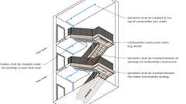
Sprinklers: Combustible Stairway Construction
Assemblies (41)
12-1.1: 1hr, Wood
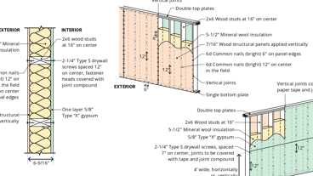
16-1.2: 1hr, Wood
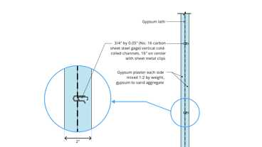
6-1.3: 1hr, Solid Gyp, Steel
6-1.2: 1hr & 2hr, Solid Gyp Plaster
6-2.2: 1hr & 2hr, Solid Gyp
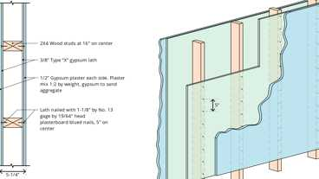
12-1.4: 1hr, Wood
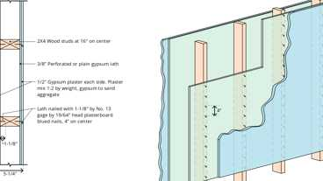
12-1.3: 1hr, Wood
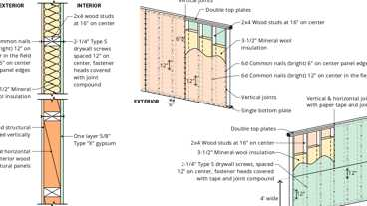
16-1.1: 1hr, Wood
27-1.1: 1hr, I-joist
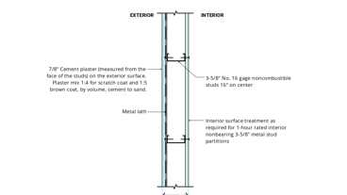
15-1.4: 1hr, Steel Stud
Show 31 more
Building products (9)
FF109-200 1 Hour Fire Rated LED Downlight Cover
Tenmat

FF109-250 1 Hour Fire Rated LED Downlight Cover
Tenmat

FF109-300 UL Fire Rated Recessed Light Cover
Tenmat

FF109-350 Fire Rated Light Cover
Tenmat

FF109-FRSC 1 Hour Fire Rated Speaker Cover
Tenmat

FF109X 2 Hour UL Fire Rated Recessed Light Cover
Tenmat

FF130 - 2x2 Fire Rated Troffer Cover
Tenmat

FF130 - 2x4 Fire Rated Troffer Cover
Tenmat

PINK® Next Gen™ Fiberglas™ Flame Spread 25
Owens Corning

Section 603 Combustible Material in Types I and II Construction
Diagram
UpCodes Diagrams (5)
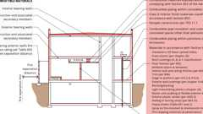
Combustible Materials in Concealed Spaces in Type I or II Construction
Type I / II: Exterior Areas Using Fire-Retardant Treated Wood
Type I / II Construction: Fire-Retardant Treated Wood Roof Construction
Roof Assembly Fire Classification
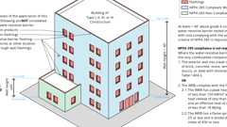
Combustible Water Resistive Barriers
Building products (2)
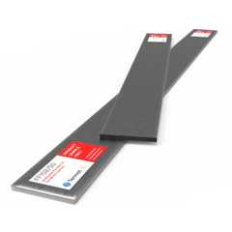
FF102/50 Rainscreen Fireblock
Tenmat

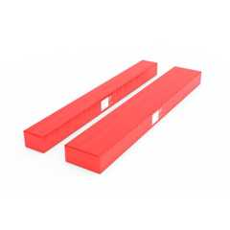
FF102/50Plus Rainscreen Fireblock
Tenmat

603.1 Allowable Materials
Diagram
Combustible materials shall be permitted in buildings of Type I or II construction in the following applications and in accordance with Sections 603.1.1 through 603.1.3:
- Fire-retardant-treated wood complying with Section 2303.2 shall be permitted in:
  - Nonbearing partitions where the required fire-resistance rating is 2 hours or less except in shaft enclosures within Group I-2 occupancies and ambulatory care facilities.
  - Nonbearing exterior walls where fire-resistance-rated construction is not required.
  - Roof construction, including girders, trusses, framing and decking.
Exceptions:
    - In buildings of Type IA construction exceeding two stories above grade plane, fire-retardant-treated wood is not permitted in roof construction where the vertical distance from the upper floor to the roof is less than 20 feet (6096 mm).
    - Group I-2, roof construction containing fire-retardant-treated wood shall be covered by not less than a Class A roof covering or roof assembly, and the roof assembly shall have a fire-resistance rating where required by the construction type.
  - Balconies, porches, decks and exterior stairways not used as required exits on buildings three stories or less above grade plane.
- Thermal and acoustical insulation, other than foam plastics, having a flame spread index of not more than 25.
Exceptions:
  - Insulation placed between two layers of noncombustible materials without an intervening airspace shall be allowed to have a flame spread index of not more than 100.
  - Insulation installed between a finished floor and solid decking without intervening airspace shall be allowed to have a flame spread index of not more than 200.
- Foam plastics in accordance with Chapter 26.
- Roof coverings that have an A, B or C classification.
- Interior floor finish and floor covering materials installed in accordance with Section 804.
- Millwork such as doors, door frames, window sashes and frames.
- Interior wall and ceiling finishes installed in accordance with Section 803.
- Trim installed in accordance with Section 806.6.
- Where not installed greater than 15 feet (4572 mm) above grade, show windows, nailing or furring strips and wooden bulkheads below show windows, including their frames, aprons and show cases.
- Finish flooring installed in accordance with Section 805.
- Partitions dividing portions of stores, offices or similar places occupied by one tenant only and that do not establish a corridor serving an occupant load of 30 or more shall be permitted to be constructed of fire-retardant-treated wood complying with Section 2303.2, 1-hour fire-resistance-rated construction or of wood panels or similar light construction up to 6 feet (1829 mm) in height.
- Stages and platforms constructed in accordance with Sections 410.2 and 410.3, respectively.
- Combustible exterior wall coverings, balconies and similar projections and bay or oriel windows in accordance with Chapter 14 and Section 705.2.3.1.
- Blocking such as for handrails, millwork, cabinets and window and door frames.
- Light-transmitting plastics as permitted by Chapter 26.
- Mastics and caulking materials applied to provide flexible seals between components of exterior wall construction.
- Exterior plastic veneer installed in accordance with Section 2605.2.
- Nailing or furring strips as permitted by Section 803.15.
- Heavy timber as permitted by Note c to Table 601 and Sections 602.4.4.4 and 705.2.3.1.
- Aggregates, component materials and admixtures as permitted by Section 703.2.1.2.
- Sprayed fire-resistive materials and intumescent fire-resistive materials, determined on the basis of fire resistance tests in accordance with Section 703.2 and installed in accordance with Sections 1705.15 and 1705.16, respectively.
- Materials used to protect penetrations in fire-resistance-rated assemblies in accordance with Section 714.
- Materials used to protect joints in fire-resistance-rated assemblies in accordance with Section 715.
- Materials allowed in the concealed spaces of buildings of Types I and II construction in accordance with Section 718.5.
- Materials exposed within plenums complying with the California Mechanical Code.
- Wall construction of freezers and coolers of less than 1,000 square feet (92.9 m²), in size, lined on both sides with noncombustible materials and the building is protected throughout with an automatic sprinkler system in accordance with Section 903.3.1.1.
- Wood nailers for parapet flashing and roof cants.
- Vapor retarders as required by Section 1404.3.
UpCodes Diagrams (7)
Primary
Type I / II Construction: Fire-Retardant Treated Wood Roof Construction
Primary
Type I / II: Exterior Areas Using Fire-Retardant Treated Wood
Primary
Wood Stud Walls in Type I & II Construction
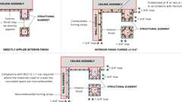
Direct Attachment & Furred Construction
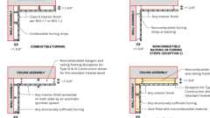
Set-Out Construction
Type IIA Construction
Type IIB Construction
Building products (13)
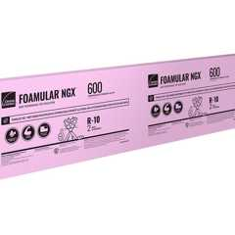
FOAMULAR® NGX® 400/600/1000
Owens Corning

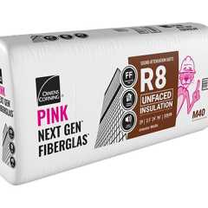
PINK Next Gen™ Sound Attenuation Batts (SAB) Metal Framing
Owens Corning

PINK® Next Gen™ Fiberglas™ Flame Spread 25
Owens Corning

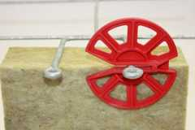
Thermafiber® RainBarrier® Clip
Owens Corning

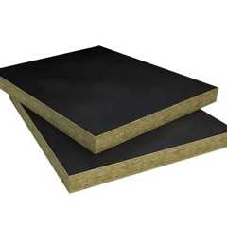
Thermafiber® RainBarrier® Dark™
Owens Corning

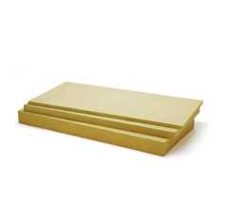
Thermafiber® RainBarrier® Semi-Rigid Insulation
Owens Corning

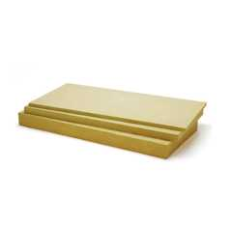
Thermafiber® RainBarrier® ci High Compressive (80)
Owens Corning

Thermafiber® RainBarrier® ci High Compressive Max (140)
Owens Corning

Thermafiber® RainBarrier® ci High Compressive Plus (110)
Owens Corning

Thermafiber® SAFB™
Owens Corning

Thermafiber® SAFB™ FF
Owens Corning

Thermafiber® Safing
Owens Corning

Thermafiber® Safing FF
Owens Corning

603.1.1 Ducts
The use of nonmetallic ducts shall be permitted where installed in accordance with the limitations of the California Mechanical Code.
603.1.2 Piping and Plumbing Fixtures
The use of combustible piping materials and plumbing fixtures shall be permitted where installed in accordance with the limitations of the California Mechanical Code and the California Plumbing Code.
603.1.3 Electrical
The use of electrical wiring methods with combustible insulation, tubing, raceways and related components shall be permitted where installed in accordance with the limitations of this code and the California Electrical Code.

